

**Registered Charity Number: 1045429**

Office 73, 4th floor, Building 7, Vantage Point Business Park,

Mitcheldean, Glos. GL17 0DD

Phone: 01594 372777 Email: [admin@ticplus.org.uk](mailto:admin@ticplus.org.uk) Website: www.ticplus.org.uk

**Job Pack**

|  |
| --- |
| **Job Pack: Marketing & Communications Lead**    Thank you for your interest in working for TIC+. The job pack consists of the following documents:   * Guidance Notes * Job Details * About TIC+ and the Role * Job Description/Person Specification   **The closing date for applications** is 15 January 2023  **Please return the following documents by the date stated above.**   1. The completed Application Form 2. The Diversity Questionnaire   **Interviews** date: **TBC**    In order to minimise our administrative costs, applicants should assume they have been unsuccessful if they have not heard from us within three weeks of the closing date. In such instances we are thankful for your interest in TIC+.  **Completed applications should be emailed to: hr@ticplus.org.uk  or sent by post to:**  Office 73, 4th floor, Building 7, Vantage Point Business Park, Mitcheldean, Gloucestershire, GL17 0DD |
|  |

**Guidance Notes**

**Filling in the application form**

* Please complete all parts of the application form. (**CVs will not be accepted in place of an application form).**
* Show clearly how your experience, knowledge, skills and abilities are relevant to the requirements of the person specification.
* Do not miss out experience gained in previous jobs but select the most relevant points. Also include details of any skills or experience gained from voluntary, committee or community work, etc.
* Use extra sheets if necessary, noting your name and the post you have applied for at the top of each sheet.
* Check the closing date to allow time for your application to reach us.
* We suggest you keep a copy of your completed application.
* TIC+ does not usually acknowledge receipt of application forms unless specifically requested and a stamped, self-addressed envelope is enclosed. **Please note that if you have not been contacted by the advertised interview date then unfortunately you have not been successful in your application.**

**Short-listing**

When short-listing we will be looking for evidence that you have the knowledge, experience, skills and abilities to do the job as detailed in the job description and person specification. These provide the essential criteria against which your application will be assessed.

**Candidates with disabilities**

TIC+ welcomes applications from candidates with disabilities. Please make us aware of any reasonable adjustments we may need to make for you and particularly address any special requirements you may have if you are invited for interview.

**Safer Recruitment**

TIC+ is committed to safeguarding and promoting the welfare of children and expects all staff to share this commitment. You will be interviewed and assessed against the criteria set out in the job description and person specification. All employment offers are made subject to the following checks

* satisfactory references
* right to work check
* satisfactory health check

The declaration section of the application form must be completed. TIC+ is an organisation that provides services for children young people and families and operates a Safer Recruitment Policy. You will appreciate therefore, that TIC+ must be particularly careful to enquire into the character and background of applicants for appointments to posts that (a) involve direct and indirect contact with children and vulnerable adults or supervise those who have direct or indirect contact with children or vulnerable adults, (b) who are in positions of trust and influence and (c) who, by virtue of the authority and responsibility inherent in the post they hold, might be expected to be positively suitable to work with children and vulnerable adults. Seeking this information is not, in anyway, to reflect upon applicants’ integrity but is necessary to protect the vulnerable and to assist us in making safe recruitment decisions.

The post is covered by the Rehabilitation of Offenders Act 1974, therefore, only unspent convictions and cautions must be declared. Details of any criminal record should be submitted with your application form in a sealed envelope marked ‘Confidential’. The information disclosed will not be kept with your application form during the application process.

Providing false information is an offence and could result in the application being rejected or summary dismissal, if the applicant is already in post, and possible referral to the police.

**We aim to make the application process as straightforward as possible. If you have any further questions regarding your application or require any further general guidance or information about TIC+ please contact a member of our Human Resources Department 01594 372777 or email** [**hr@ticplus.org.uk**](mailto:hr@ticplus.org.uk)

Thank you for considering applying to TIC+

**About TIC+**

TIC+ is a charity established in 1993 serving Gloucestershire and surrounding areas. TIC+ reaches hundreds of children and young people every year as well as offering support & advice to parents & professionals. We work to ensure that every young person has easy, prompt, independent access to appropriate support according to their needs. We offer:

* Counselling – online, remote (video & phone) and face-to-face for children and young people
* Anonymous online helpline for children and young people
* Counselling support for young people with eating difficulties
* Parent Support
* Psycho-educational workshops for children, young people, parents & professionals

TIC+ has a head office in Mitcheldean Gloucestershire; counselling rooms and home-based staff and volunteers working across the county. We strive to ensure young people, parents and families feel accepted, safe & valued, so that they can say what’s on their mind, and be really listened to without the fear of being judged. We work with young people to help them build resilience & give them strategies to cope with situations they might be facing.

**Our Ethos:**

TIC+ is a Christian led charity that is not affiliated to any particular denomination, church or group.  We provide services to anyone of any faith or none and we employ staff from any faith or none. As an organisation we believe that the Christian faith provides the foundation and motivation for the work of the charity and is the reason why we do what we do. Our mission *to improve, preserve and promote good mental health and wellbeing amongst children, young people and families* is borne from Jesus’ words; *“I have come that they may have life, and have it to the full.”*

The Christian faith is not explicit in any of the services we provide. An outworking of our ethos means that we expect all representatives of the charity to treat everyone equally, with care and respect regardless of their race, gender, religion, sexual orientation, ethnic background, beliefs, status, ability or class. The ethos is given life through our relationships; the way we work together and behave with one another and those we serve, are a demonstration and authentication of our ethos.

**Our Values:**

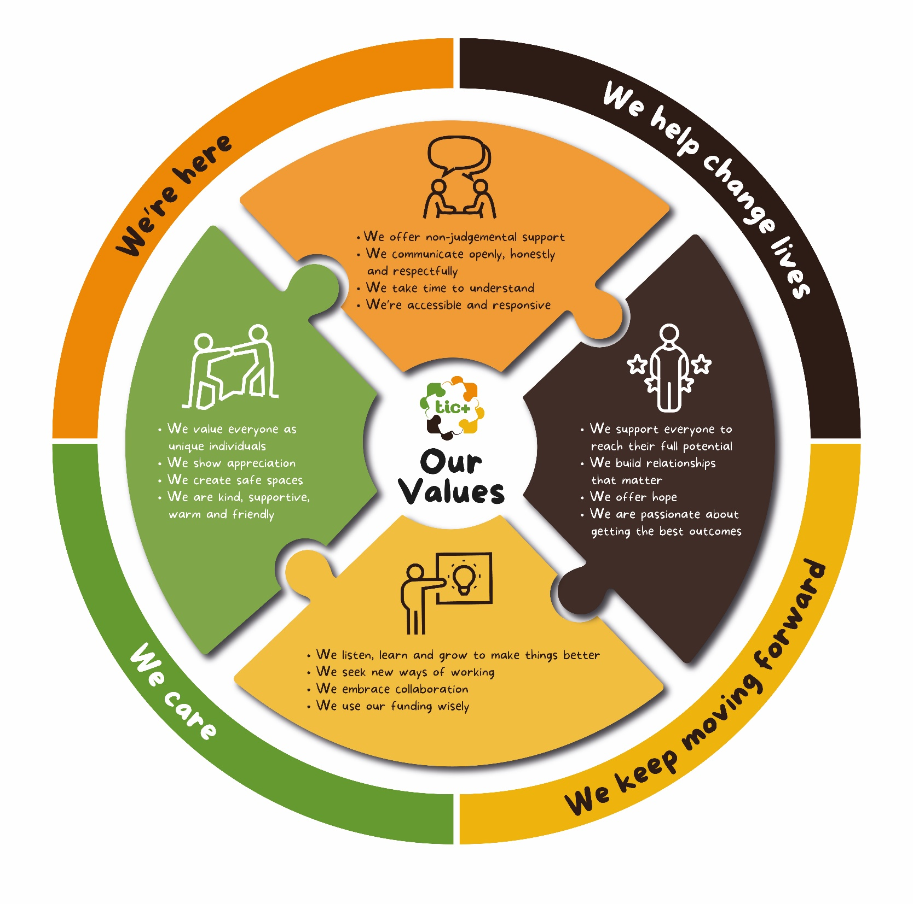

**Job Description**

**Job Title:** Marketing & Communications Lead

**Salary:** Salary£32,935 (£16.89 per hour)

**Hours:** F/T37 hours per week

**YOU MUST BE ABLE TO COMMIT TO BEING IN THE OFFICE 4 DAYS PER WEEK IN Mitcheldean, Gloucestershire** with the opportunity to work an additional one day from home.

**General Description**

The main purpose of the role is to support the work of TIC+ in its engagement with young people and supporters, through marketing and communications using social media, website, presentation and online/printed materials. The MarComms Lead will develop and deliver the TIC+ marketing and communications strategy, ensuring that it lands with impact among external and internal audiences.

You will work to build on current levels of engagement with young people, families and supporters in all settings including schools, businesses and at home. You will devise content to promote our counselling services, fundraising activities and events, and other campaigns as required, and enhance the engagement experience of followers.

You will ensure our values resonate with supporters, funders and the young people and families we are here to support. Your established marketing and communications skills will contribute towards the creation of effective and memorable campaigns, which deliver against the strategic objectives of the organisation.

In return you will enjoy the support of an organisation committed to those we support, our staff and supporters. We will invest in you, your passion and purpose because we want to motivate you, and everyone who works with us, to make a difference to the lives of young people and their families, and the county in which we operate.

You will be a considered individual, who cares about people, and making a difference where it matters most. This role requires an individual who is driven to support TIC+ to achieve its ambitions at pace, today and in the future.

**Reports to**: Head of Fundraising & Communications

**Internal Relationships:** Working as part of the Fundraising team, the Marketing & Communications Lead will ensure delivery of all marketing and communications activity in support of the services we provide, all fundraising activity and support to all TIC+ teams. It is expected that this role will support growth in our services and income generation and will be an integral part of our future sustainability.

**Key Relationships:** Head of Fundraising & Communications, Community & Events Fundraiser, Fundraiser, Director of Operations, Director of Counselling Services, Data and IT team, Referral team, Training team.

**Terms:** Full-time, permanent. There will be a 6-month probationary period where the successful candidate’s suitability for the role will be assessed.

**Qualifications and Experience:**

1. **Excellent Communication Skills** – including writing skills for web, social media and other. You will be a talented wordsmith, have excellent attention to detail and will be able to check and proof read for accuracy.
2. **Ideally, experience within a communications, marketing or digital role including**:

* Experience/ability to operate and develop social media channels (Facebook, Instagram, Twitter, LinkedIn) and developing engaging content, including short videos and reels
* Marketing and campaign planning experience
* Experience of using design software (Canva/Crello, Adobe Creative Suite) for digital and print design
* Understanding of SEO, Google Analytics and organic/paid social.

**Personal Specification:**

* Established communication and marketing skills
* Marketing campaign planning and execution experience
* Social media and website development experience
* Sense of humour
* Organisation and administration skills
* Innovation and creativity
* Educated to at least ‘A’ Level standard with relevant experience
* Car owner and clean driving licence
* Team player but able to work independently
* Excellent time management and the ability to work well under pressure and to deadlines.

**Role and Responsibilities:**

Reporting into the Head of Fundraising & Communications (HOFC) you will be responsible for the operational management, development and delivery of our marketing and communications. This will include the day to day production of all communications and marketing materials for a range of campaigns involving social media, content, email, events and branding, including:

* Producing a MarComms strategy and implementation plan, to reflect the strategic aims of the organisational strategy. Deliver this plan against measurable objectives and outcomes.
* Creating a professional MarComms approach and toolkit aligned with the organisation’s strategy and plans
* Creating content and collateral which is on brand and designed for young people, supporters and professionals.
* To use Meta Business Suite to create content and update social media across Facebook and Instagram, as well as other platforms for Twitter, LinkedIn and YouTube, to promote the aims of TIC+.
* Content creation, updating & maintenance of TIC+ WordPress website for review by the HOFC. Main contact in liaising with external web agency when necessary.
* Monitoring of TIC+ social media and ensuring that queries or requests are directed to the right employees for response.
* Previous experience of using customer insight to inform campaigns, creative brief development, messaging, and media choices.
* Support the delivery of internal and external Newsletters using Mailchimp and any other platform.
* Create audience data briefs and work with data team to get the correct data for communications channels.
* Capturing events for marketing posts via photos/video as required. This includes digitally editing videos and content into a presentable publishing format for social media.
* Writing, proofreading and copy editing as required across departments, for sign off by Managers and HOFC.
* Supporting delivery of the Annual Report and other publications.
* Act as main point of contact with Training Team for marketing and design of all courses and collateral.
* Ensure that all marketing and communication is correct in spelling and grammar; always reflecting well on the TIC+ brand.
* Use analytical tools and regular reports on effectiveness of website content to improve SEO, Conversion and other goals.
* Ensure that the HOFC is alerted to any social media posts that could reflect negatively on the TIC+ brand so that they may respond accordingly to management.

**Fundraising responsibilities**

To support the fundraising team with the following tasks:

* + To lead on the creation and delivery of fundraising Newsletter, using Mailchimp
  + To oversee promotion and delivery of fundraising campaigns
  + Help in interpretation and graphical representation of user statistics for funding reports
  + Supporting development of new marketing collateral.

The above is not an exhaustive list of duties and you will be expected to undertake, from time to time, any other duties that may be required of you to support the effectiveness of TIC+ overall, and which are consistent with the basic objectives and/or duties of the post.

It is the nature of the work that tasks and responsibilities are in some circumstances unpredictable and varied. You will be expected to work in a flexible way that may, on occasions, include weekend and evening working such as attending events and social media posting/responding.

**General**

* To work in a collaborative, collegiate way to support whole team coverage and output
* To be an active member of the Fundraising Team, contributing to organisational plans and cross-departmental projects
* To participate fully in regular one-to-one supervision sessions and in an annual performance appraisal
* To be pro-active in maintaining personal and professional learning and development and identify own training needs as they arise
* To attend team meetings, away days and other similar events
* To promote equality, diversity and rights in all publications and communications
* To contribute to the overall success of TIC+ and support a positive inclusive culture through teamwork, communications and leadership.

# External Liaison

# Promote TIC+ and our work when appropriate to clients and supporters, at arranged talks at community groups, churches, social groups and various other venues.

# Holidays:

You will receive a paid holiday entitlement of 5.6 weeks inclusive of public/bank

holidays (pro-rata for part-time employees). An additional day’s leave is awarded annually on completion of successful probationary period

Operational closure between Christmas and New Year (discretionary).

**Expenses:**

Legitimate business expenses incurred as part of carrying out your job will be reimbursed.

**PERSON SPECIFICATION**

|  |  |  |  |  |  |  |  |
| --- | --- | --- | --- | --- | --- | --- | --- |
| **Job Title:** | **Marketing & Communications Lead** | | |  | | |  |
|  | | ESSENTIAL | DESIRABLE | | METHOD OF ASSESSMENT |
| ***QUALIFICATIONS*** | | Educated to ‘A’ level standard | Educated to degree level | | * Application Form * Certificate Check |
| ***EXPERIENCE*** | | Experience in a similar role for a charity or other organisation  Working with website content management systems, particularly WordPress  Maintaining social media channels  (Facebook, Instagram, Twitter, LinkedIn; TikTok desirable)  Creating content for digital platforms  Marketing campaign planning experience | Experience in email marketing  Experience building and monitoring paid for and organic social campaigns | | * Application Form * Interview |
| ***SKILLS*** | | Strong writing, editing and proofing abilities, excellent attention to detail  Ability to multi task and work on multiple projects to tight deadlines in a fast-paced environment  Good eye for design  Proactive in learning new skills and keeping up to date  Able to use initiative, taking ownership of areas of responsibility and reporting back  Analytical thinker, able to use data to inform decisions and shape work  Ability to work under pressure and unsupervised | Knowledge of Adobe suite including Photoshop and InDesign  Knowledge of video production and basic editing  Knowledge of podcasting and relevant software  Knowledge of Google Suite including analytics and AdWords | | * Application Form * Interview * Skills test |
| ***PERSONAL QUALITIES***  (*Demonstrable*) | | Enthusiastic and passionate about the aims of the charity and seeing young lives transformed  Good people skills, able to use emotional intelligence to engage positively with a range of personalities  Dynamic, energetic and enthusiastic approach to work  Highly organised, able to meet deadlines and bring others to do the same  Hard working self-starter who relishes a challenge and is able to pro-actively work on own initiative  Optimistic outlook, focusing on solutions as opposed to problems  Energised by working to achieve high standards  Target driven and audience-centric approach  Brings a positive, friendly, calm, professional and helpful disposition to the team  Adaptable and open to change with a flexible approach to the needs of the post e.g. may require working outside of normal working hours. |  | | * Application Form * Interview |
| **OTHER**  (*Please Specify*) | | To be an ambassador for TIC+ promoting the wider work and interests of the charity where appropriate  To demonstrate a commitment to equal opportunities and anti-oppressive / anti-discriminatory practice.  To support the Christian ethos and the aims and objectives of the charity. |  | | * Interview |